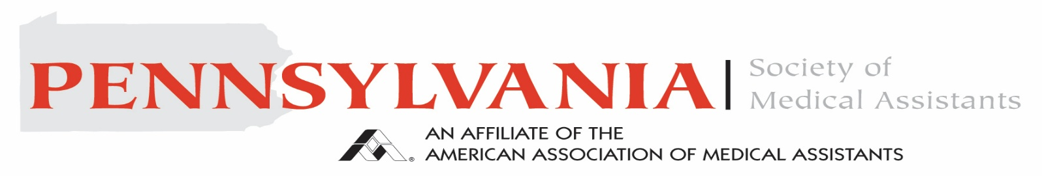
In conjunction with


Spring Education and BOT Meeting 20265

Date: Saturday, March 21st, 2026
Time: 7:30 AM to 3:30 PM
Location: Penn State Health University Conference Center
30 Conference Drive C Street
Hershey PA, 17033

The event is free to all Pennsylvania Society of Medical Assistants. You must be current with your AAMA dues in order to attend. We will be offering 6 CEUs. Please see attached for Agenda and Registration. We are collecting adult incontinence briefs for the Central PA Diaper bank. Bring a pack of briefs and be entered in a giveaway drawing.

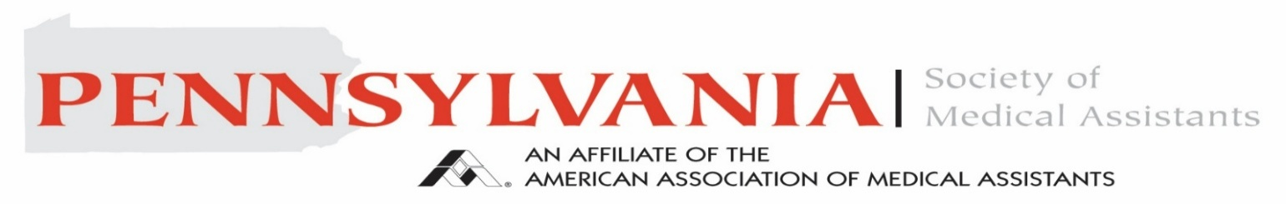
In conjunction with

Agenda
7:30 AM- 8-00 AM Continental Breakfast/ Registration
8:00 AM-9:00 AM Nature Bathing Matthew Silvis, MD
9:00 AM-10:30 AM BOT Meeting
10:30 AM-11:30 AM Charcot Marie Tooth Michael Aynardi, MD
11:30 AM-1:00 PM Lunch (On Your Own)
1:00 PM-2:00 PM PSD in Health Care Kelly Fuddy
2:00 PM-3:00 PM Legal Documentation for the MA Christine Desantis

<--------------------------------------------------------------------------------->
Name: __________________________________ ID#: _______________________
Address: ______________________________________ Phone #____________________ ______________________________________________
Email: _________________________________________
Please mail registration to: Kellie Humma, CMA (AAMA)
192 Scenic Ridge Blvd. Lebanon, PA 17042
Registration is due by Friday, March 6th. If you do not want to be in photos, please let us know.
Schedule Subject to change.

