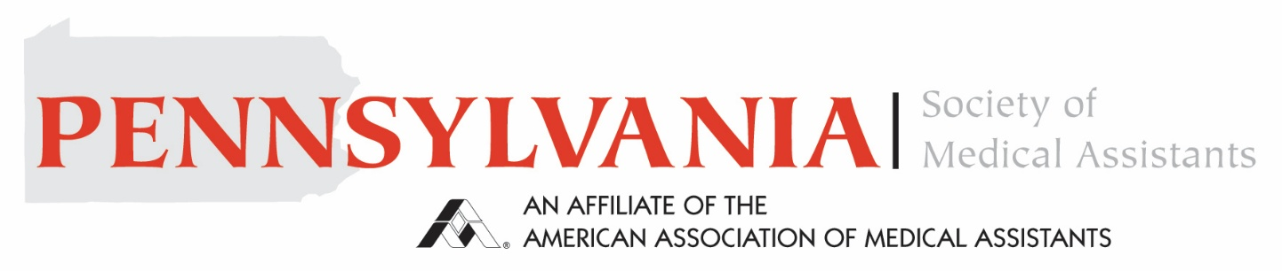

Pennsylvania Society of Medical Assistants State Conference and BOT Meeting 2026
Where: Harrisburg Area Community College
CEUs offered: 7.5 CEUs
When: Saturday, May 16th, 2026
Cost: Free for Members of the PA Society of Medical Assistants
Registration is due by Friday, May 1st, 2026
Questions: call Kellie Humma CMA (AAMA) 717-269-9113
Return Printed / typed registration to:
Kellie Humma, PSMA President: 192 Scenic Ridge Blvd. Lebanon, PA 17042

*************************************REGISTRATION ****************************
Name ___________________________________ Member ID#____________________
Student ID and School Affiliation____________________________________________
Address: ___________________________________ Phone#________________________
EMAIL ADDRESS: _________________________________________________________
New officers will be elected. If interested in serving please send me an email.
khumma68@gmail.com
Schedule is subject to change.
If you do not want your picture taken, please let us know.

Agenda
Pennsylvania Society of Medical Assistants State Conference 2026

7:00 – 8:00 Registration and Continental Breakfast

8:00 – 9:00 Pediatric Scoliosis Mariano Garay, MD

9:00 – 10:30 BOT Meeting and Elections

10:30 – 11:30 Ayurvede Nichole Harman, BSN

11:30 – 1:00 Lunch (on your own)

1:00 – 2:00 Part two Dula Andria Unzaga

2:00 - 4:00 Stop the Bleed Amy Bollinger, BSN

You will receive a certificate for Stop the Bleed as well as your CEUs. Bring an Adult Incontinence product to be entered into a raffle for a $50.00 Gift Card. Schedule is subject to change.

