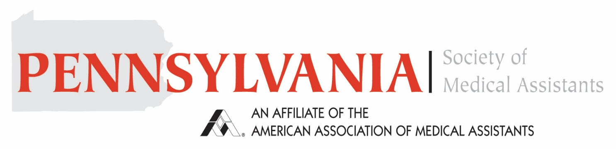
In conjunction with
Lehigh Valley Health Network
Lehigh Valley Education Day

Date: Saturday, March 28th, 2026
Time: 7:30 AM to 12:00 PM
Location: Lehigh Valley Center for Healthcare Education
3900 Sierra Circle
Center Valley, PA, 18034

The event is Free to all AAMA/Pennsylvania Society of Medical Assistants. You must be current with your AAMA dues in order to attend. We will be offering 6 CEUs. Please see attached for Agenda and Registration.

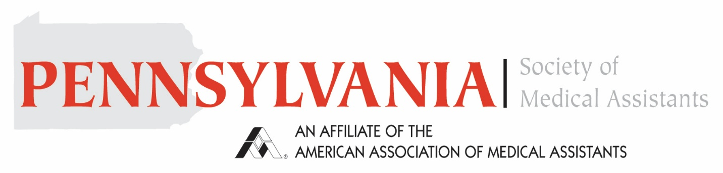
In Conjunction with
Lehigh Valley Health Network
Agenda
7:30 AM – 8:00 AM Breakfast / Registration
8:00 AM – 9:00 AM Developing an Excellent Medical Assistant Sherri Steele
9:00 AM – 10:00 AM Communicating Effectively with Alzheimer’s Patients
Katheryn Kearney
10:00 AM – 11:00 AM Human Trafficking Carol Anderson
11:00 AM – 12:00 PM Patient De Escalation Jennifer Merrick
-----------------------------------------------------------------------------------------------------------------------

Name: _______________________________________ ID#___________________

Address: ______________________________________ Phone #________________

Email: ________________________________________
Please mail registration to: Kellie Humma, CMA (AAMA)
192 Scenic Ridge Blvd. Lebanon PA, 17042
Registration is due By Friday, March 13th. If you do not want to be in photos, please let us know. Schedule Subject to Change.

