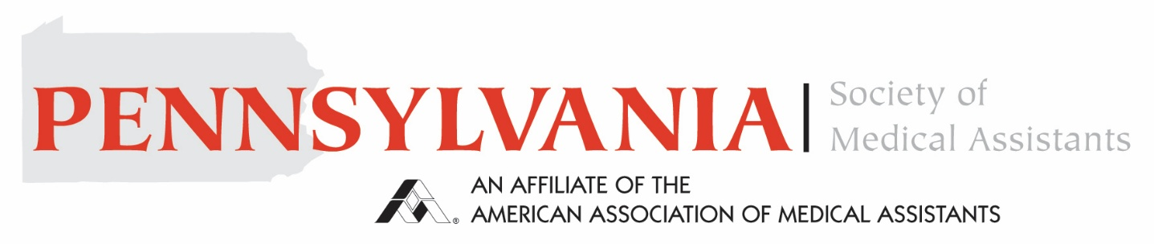
Pennsylvania Society of Medical Assistants Keystone Award
Purpose: To annually recognize an outstanding AAMA member medical assistant from Pennsylvania who demonstrates commitment to the profession, gives compassionate care to patients, and is involved in their community
Nominee Information
Name Click or tap here to enter text.
Company/Organization (if applicable) Click or tap here to enter text.
Title/Position (if applicable) Click or tap here to enter text.
Address Click or tap here to enter text.
Phone Number Click or tap here to enter text.
Email Address Click or tap here to enter text.
Nominator Information
Name Click or tap here to enter text.
Company/Organization (if applicable) Click or tap here to enter text.
Title/Position (if applicable) Click or tap here to enter text.
Address Click or tap here to enter text.
Phone Number Click or tap here to enter text.
Email Address Click or tap here to enter text.
Please attached a letter or provide a statement below supporting your nomination highlighting the nominee’s qualifications and providing examples of the individual’s commitment to the profession, patients, and the community.
Click or tap here to enter text.

Nominator’s Signature Click or tap here to enter text.
Date Click or tap to enter a date.
The nomination is submitted to pamedicalassistants1@gmail.com

