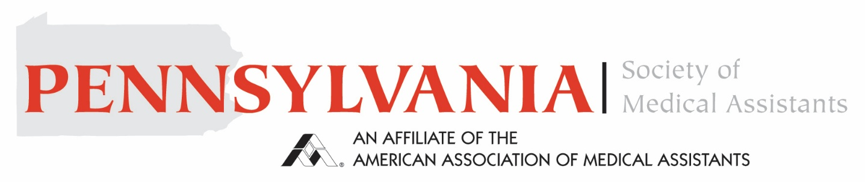
Pennsylvania Society of Medical Assistants Hardship AAMA Membership Award
Purpose: To assist with the AAMA annual dues for an AAMA member medical assistant from Pennsylvania who has experienced a hardship (disaster, a major medical issue, or unexpected unemployment)
Eligibility Note: Must be current or recent AAMA member for consideration and members are only eligible to receive this award once.
Requirements
Name Click or tap here to enter text.
Address Click or tap here to enter text.
Phone Number Click or tap here to enter text.
Email Address Click or tap here to enter text.
I am a Current AAMA Member ☐
Recent AAMA Member ☐
(must have been a member in the last 3 years to qualify)
Statement of need of assistance with hardship. Please include the nature of the hardship, current duration or anticipated end, if know, and any other information pertinent to your request.
Click or tap here to enter text.
Applicant Signature Click or tap here to enter text.
Date Click or tap to enter a date.
The request is submitted to pamedicalassistants1@gmail.com

